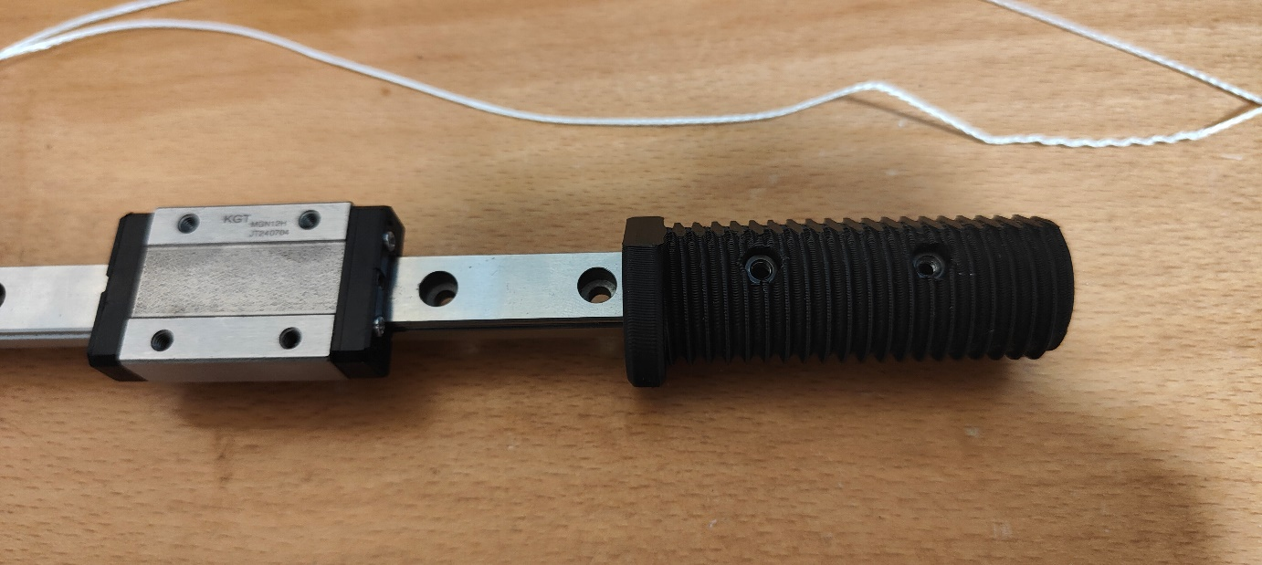

1. Insert 2 M3 Nuts into the back of the Main Part of the End Effector. Make sure they are properly seated, e.g. by screwing the min from the other side

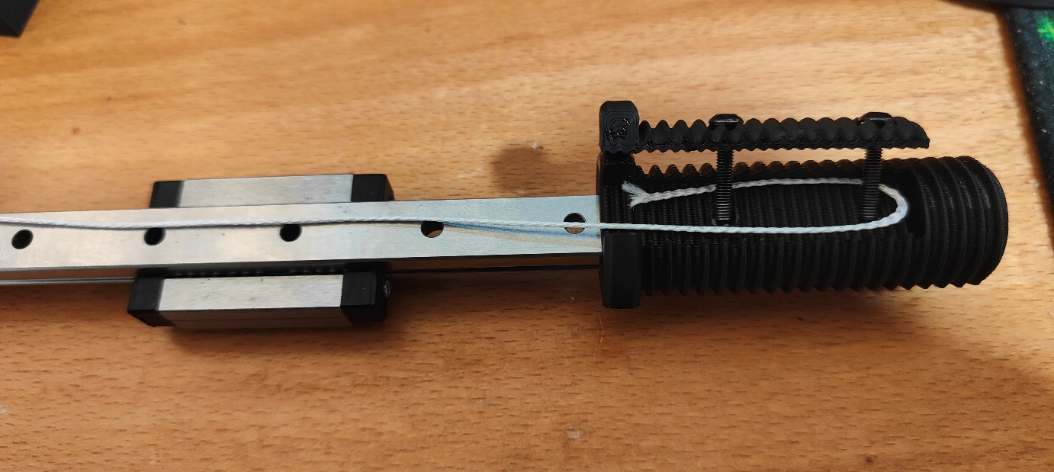

1. Slide the End Effector onto the rail in the shown orientation. Lay the rope into the teethed channel in a U-Shape.DO NOT CUT THE ROPE YET. Insert 2 M3x16 ISO7380 Screws into the Top Part of the End Effector and screw it on hand tight. Be careful not to destroy your screw heads.

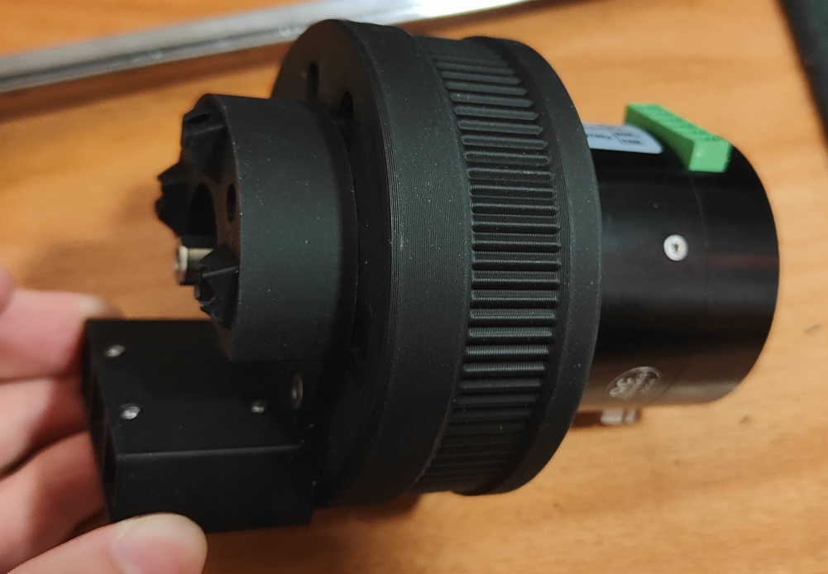

1. Insert 5 M5 Nuts into the Back of the back of the Motor Head. Again, make sure they are seated properly. Screw the Back Part of the Motor Head through the PitClamp Ring into the Motor with 2 M3x12 Countersunk and 2 M3x12 Hex Cap Screws.

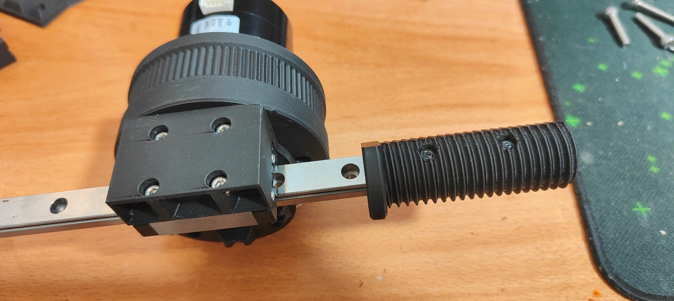

1. Screw the Motor Head onto the Rail wagon in the shown orientation with 4 M3x12 Hex Cap Screws.

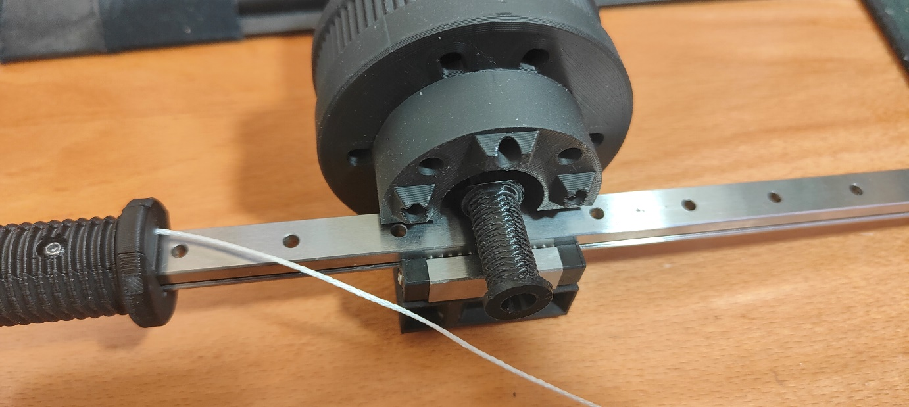

1. Turn the motor shaft so that the flat side points up. Slide the Pulley onto the motor shaft just so far that it sits somewhat stable. This makes the wrapping easier.

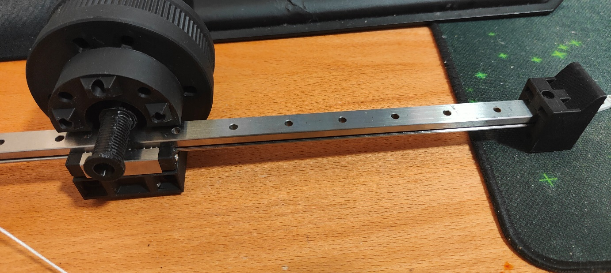

1. Slide the Rail Mount Part of the tensioner onto the other end of the rail in the shown orientation. Do not screw it in yet. Move the Motor Head to around the Middle of the Rail.

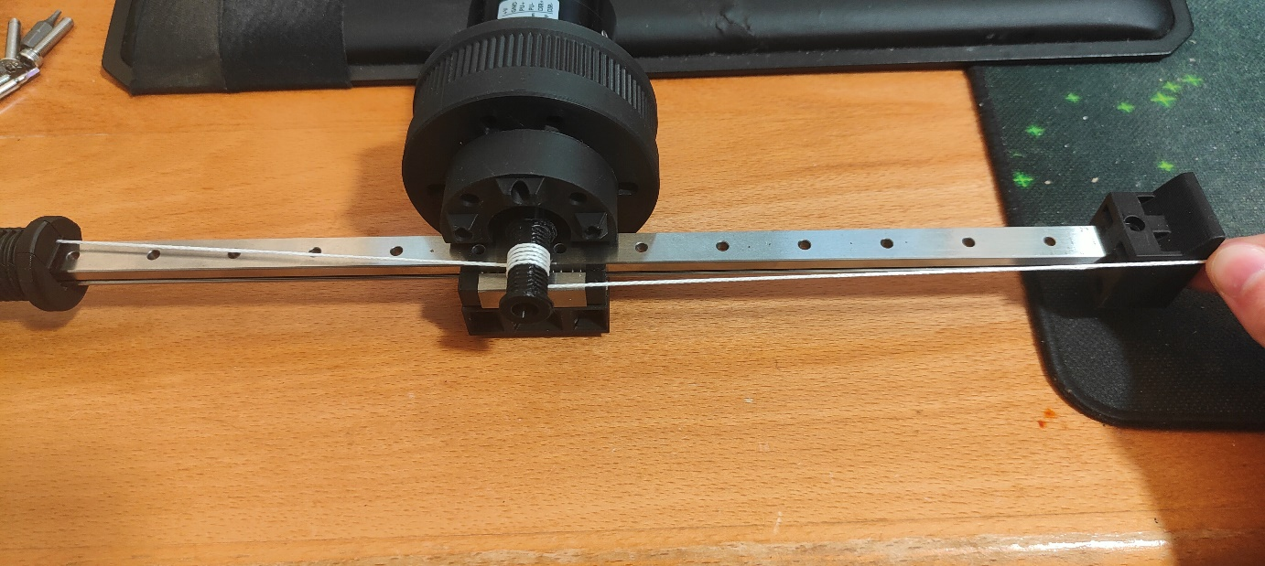

1. Wrap the rope around the Pulley. Loop from underneath the pulley upwards, counterclockwise. Wrap it around 5 times so that the 5 wraps are in the middle as best as possible. See picture. Keep the rope tensioned while wrapping.

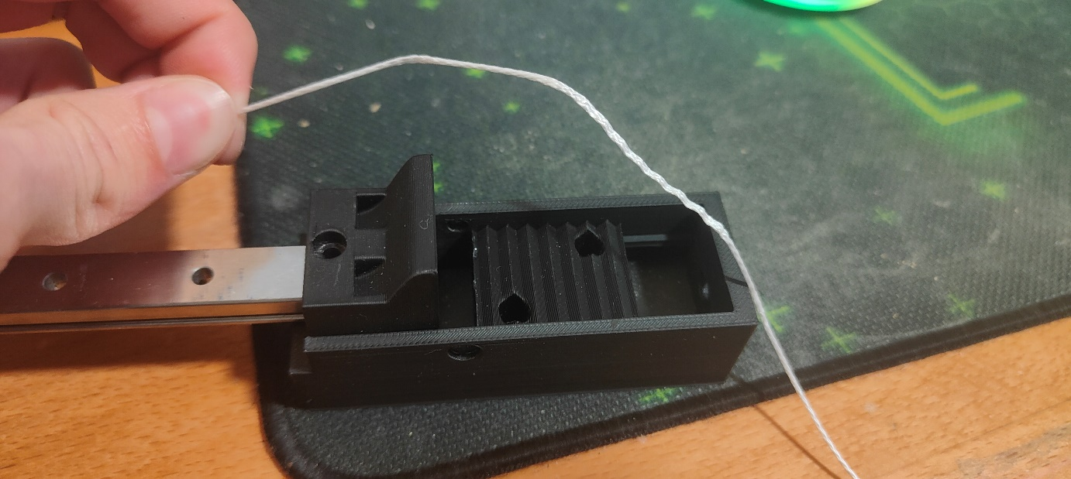

1. Place a M3 Nut into the Underside of the Slider Part of the tensioner as well as in the side. Place 2 M5 Nuts into the underside and another one into the side of the lower part of the rope clamp. Also place 2 M5 Nuts into the back of the Rail Mount. Slide the Lower Part of the rope clamp into the slider and place the slider underneath the Rail Mount like shown above.

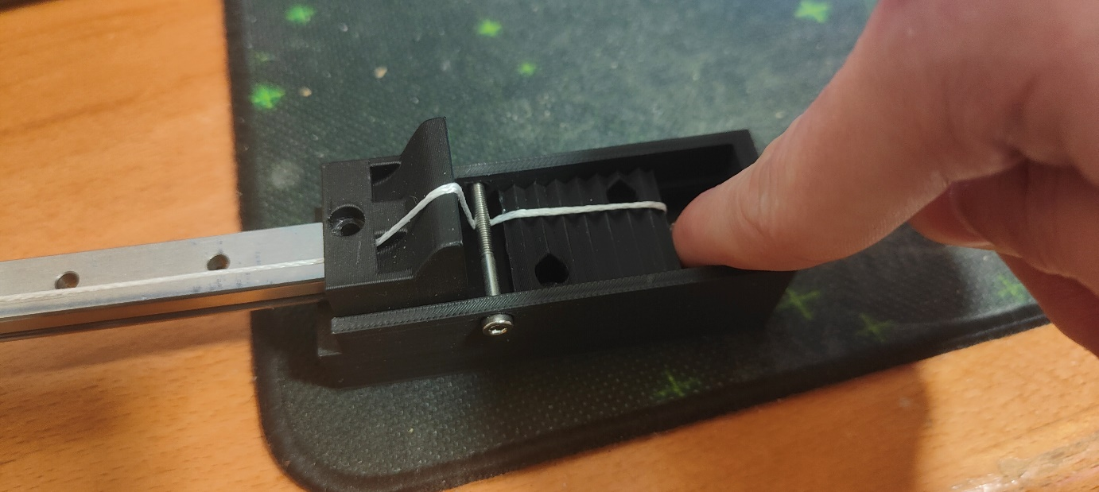

1. Guide the rope through the right hole, over the slope and down. Screw in a M3x30 Screw slightly like shown. Tension the rope over the Teeth of the clamp.

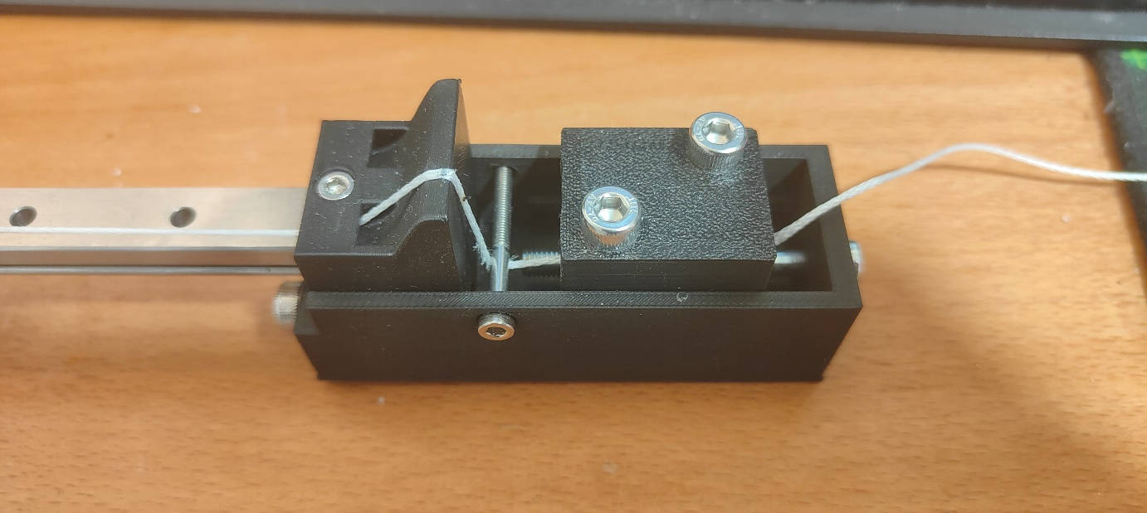

1. Screw in the upper part of the rope clamp on top of the lower part with 2 M5x25 screws. Make it tight. Screw another 2 M5x25 screws through the front of the Slider through the rail Mount into the nuts at the back. Screw in the Rail Mount with a M3x30 Screw. Finally, Put the M5x50 Bolt through the back of the Tensioner through the lower part of the rope clamp. To Tension, just tighten the screw. With the Motor Head in the middle of the rail, tension the rope but not too much.
2. Last but not least, fully insert the Pulley and screw it in with a M4x16 Screw. Not too tight here as well. You will need a plier to hold the pulley in place. Screw the front part of the Motor Head on top with 5 M5x35 Countersunk screws.
3. You will need to play around with it a bit to see if everything works, and retention should the rope stretch a bit.